Volunteer Manual
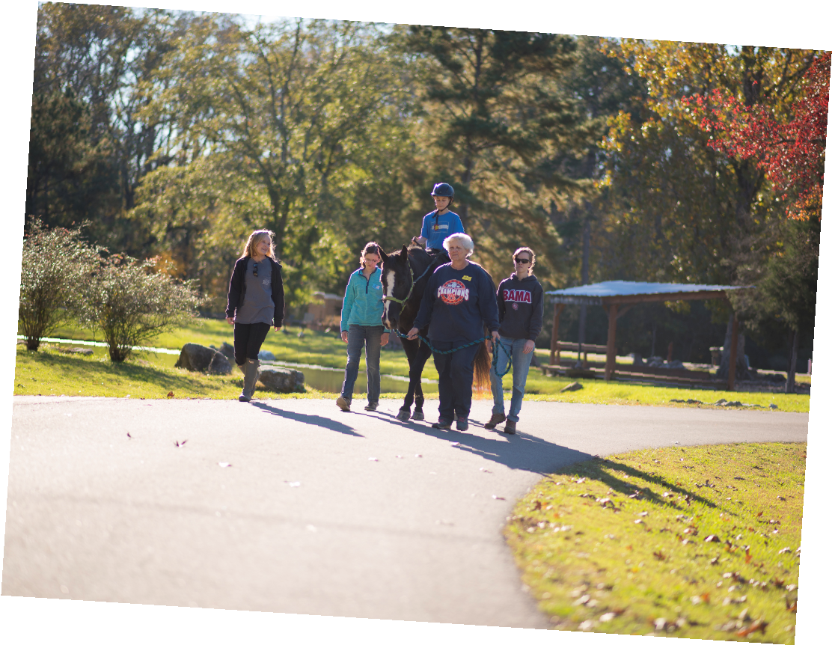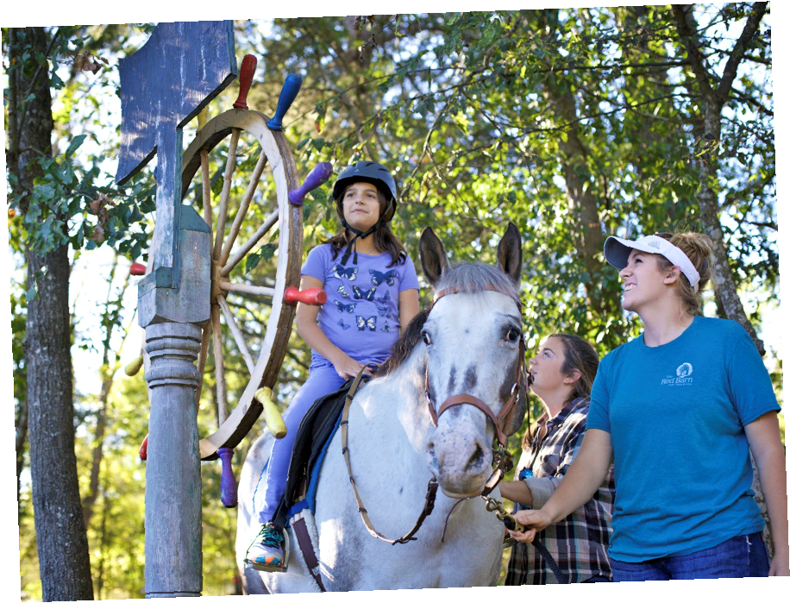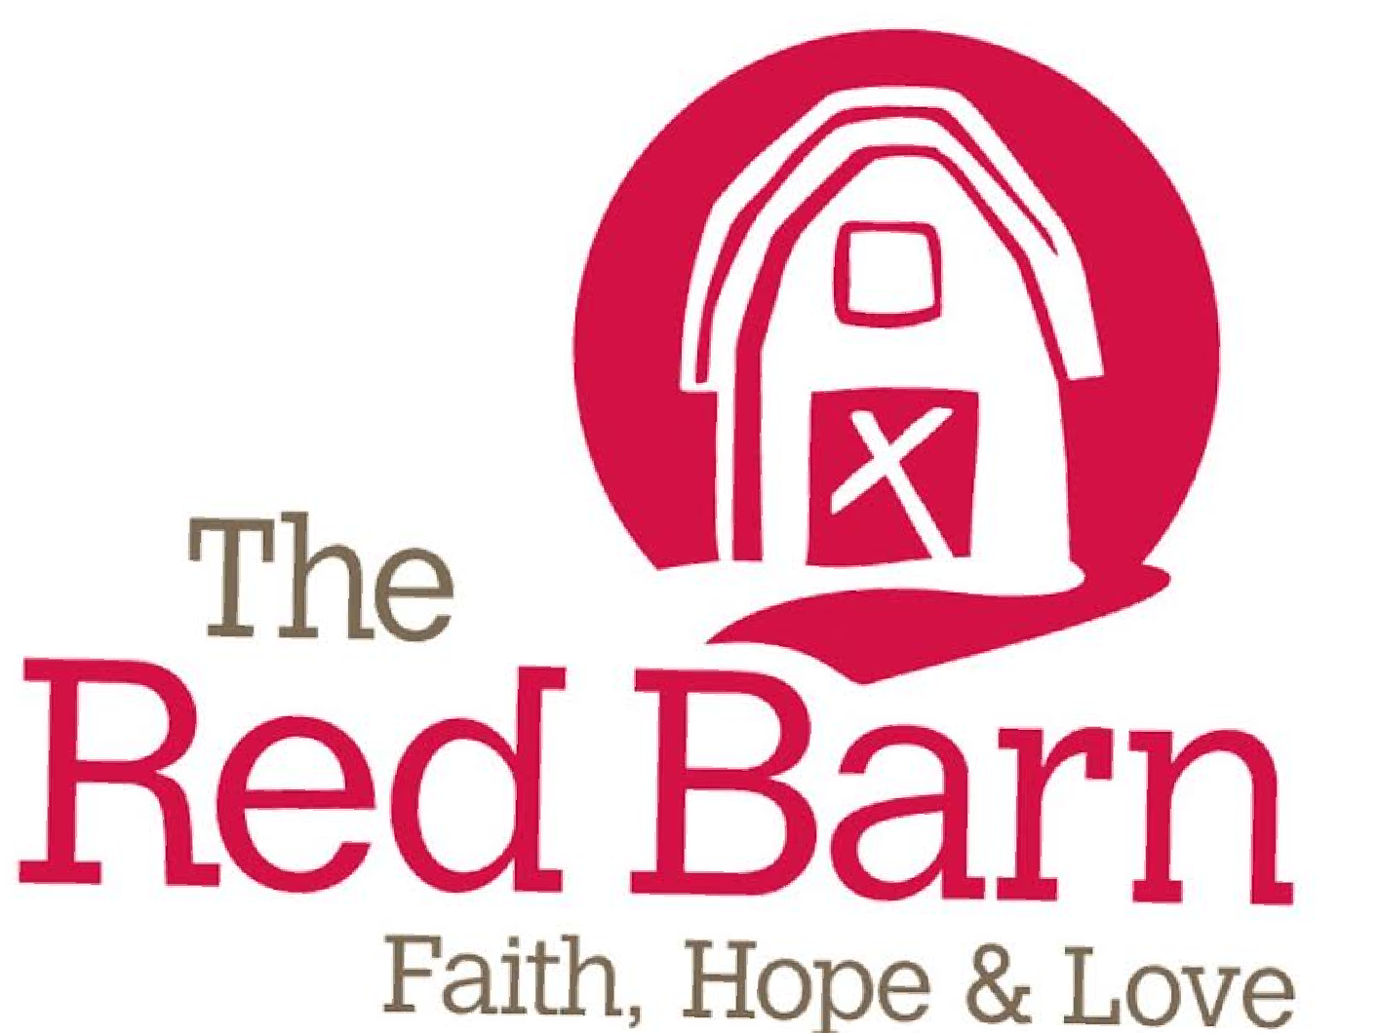

Dear Volunteer,
Thank you so much for your interest in volunteering at The Red Barn, and welcome! We are happy that you are becoming a part of our barn family. Please know that we always want you to feel valued and like you belong here, and we sincerely hope that you get as much out of this experience as you can. We want to help you learn and grow as both a person and a volunteer during your time at the barn.
With every hour you spend volunteering, you will be changing the life of a low-income child with disabilities. Your efforts will make the difference that gives that shy little girl confidence or that troubled teen peace. Thank you!
Our responsibilities are to help you be prepared for the tasks you are assigned, to communicate the students needs to you, and make sure you realize how great YOU are! We appreciate everything YOU do. We have the best volunteers around - you are joining a great team.
Looking forward to serving together,
The Red Barn Staff
Galatians 5:13
"It is absolutely clear that God has called you to a free life…use your freedom to serve one another in love; that's how freedom grows."

About Us
Our Mission Statement: The mission of The Red Barn is to promote and provide equine-assisted services to individuals of all abilities and special circumstances, especially children.

History: The Red Barn became a separate 501(c3) organization in February 2012 while operating in the little red barn on the property. Growth and word spread quickly, expanding our programs and spreading programs out over 32 acres of property by 2016.

What we do: We offer children and adults with disabilities and special circumstances the opportunity to work with and learn to ride horses.

Safety: The safety of our students, their families, as well as our staff, volunteers, and horses are of the utmost concern at all times. You will notice many signs posted around the facility - please pay attention to all of them. One of your primary responsibilities is to help us maintain our high standards of safety. If you see a safety concern, please alert the staff with discretion as soon as possible.

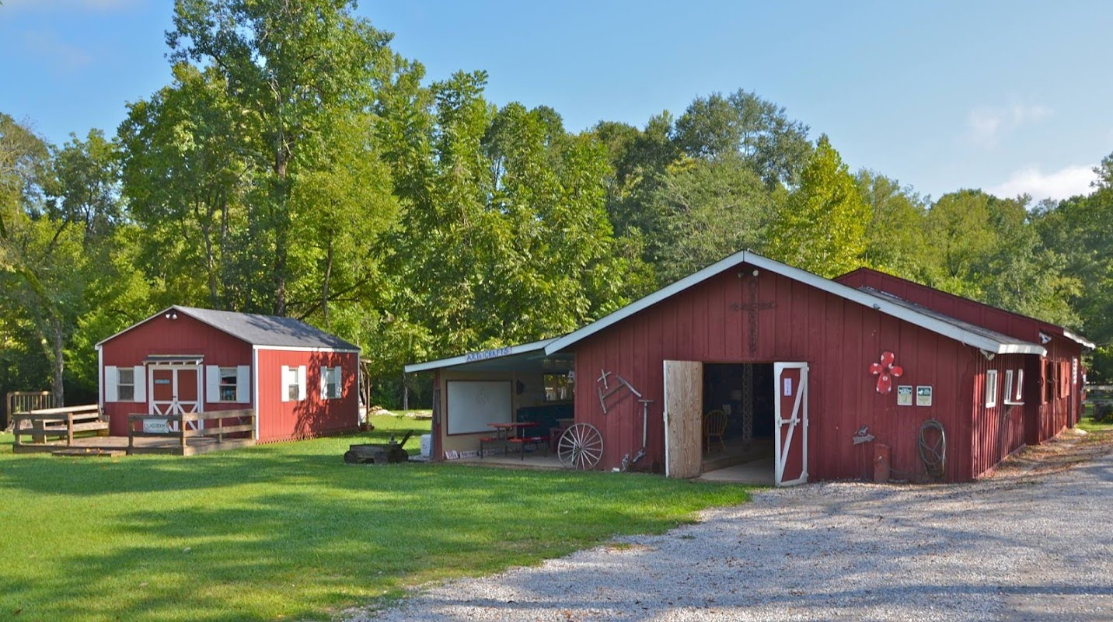

Our Programs

Equine Assisted Learning
Educational camps and classes are taught by employees with knowledge of disabilities and experience adapting activities to encourage participation.
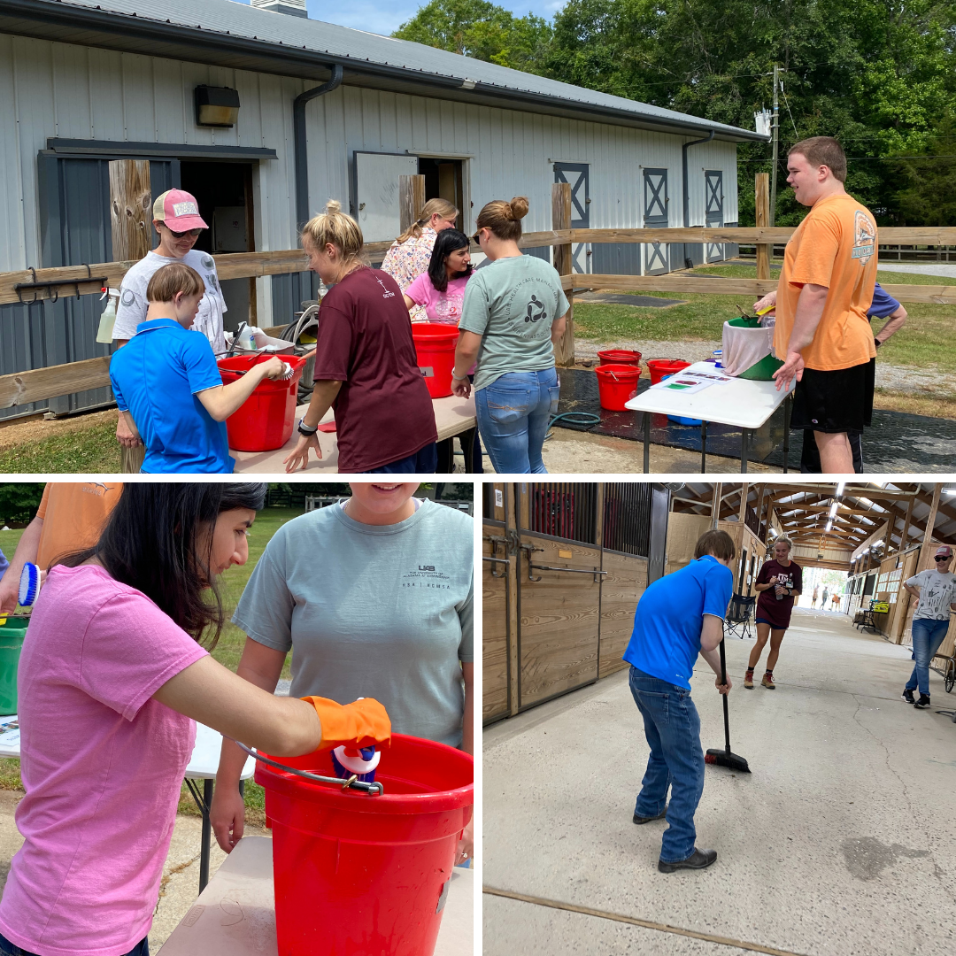
Our camps and classes give children a chance to participate in educational and recreational activities in an outdoor setting.
Sessions are "ground-based," meaning that participants do not ride. Our animals, like rabbits, goats, and horses, provide a chance for children to learn life skills through a variety of interactions. Examples of interactions include observations of herd dynamics, leading activities, grooming, or the inclusion of animals in the learning activities.

Equine Assisted Horsemanship
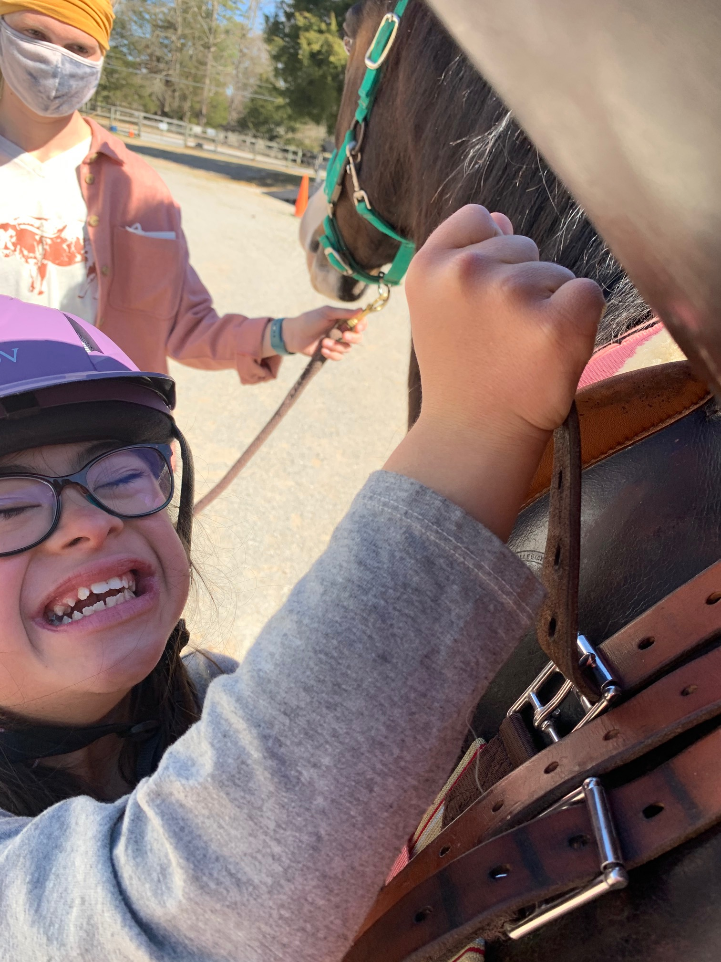
Certified Therapeutic Riding Instructors teach therapeutic horseback riding lessons at the barn. Lessons focus on proper riding position and riding skills. The strategies for riding skills are adapted based on the abilities of the rider. The rider is taught how to use their body to influence the horse's movement.
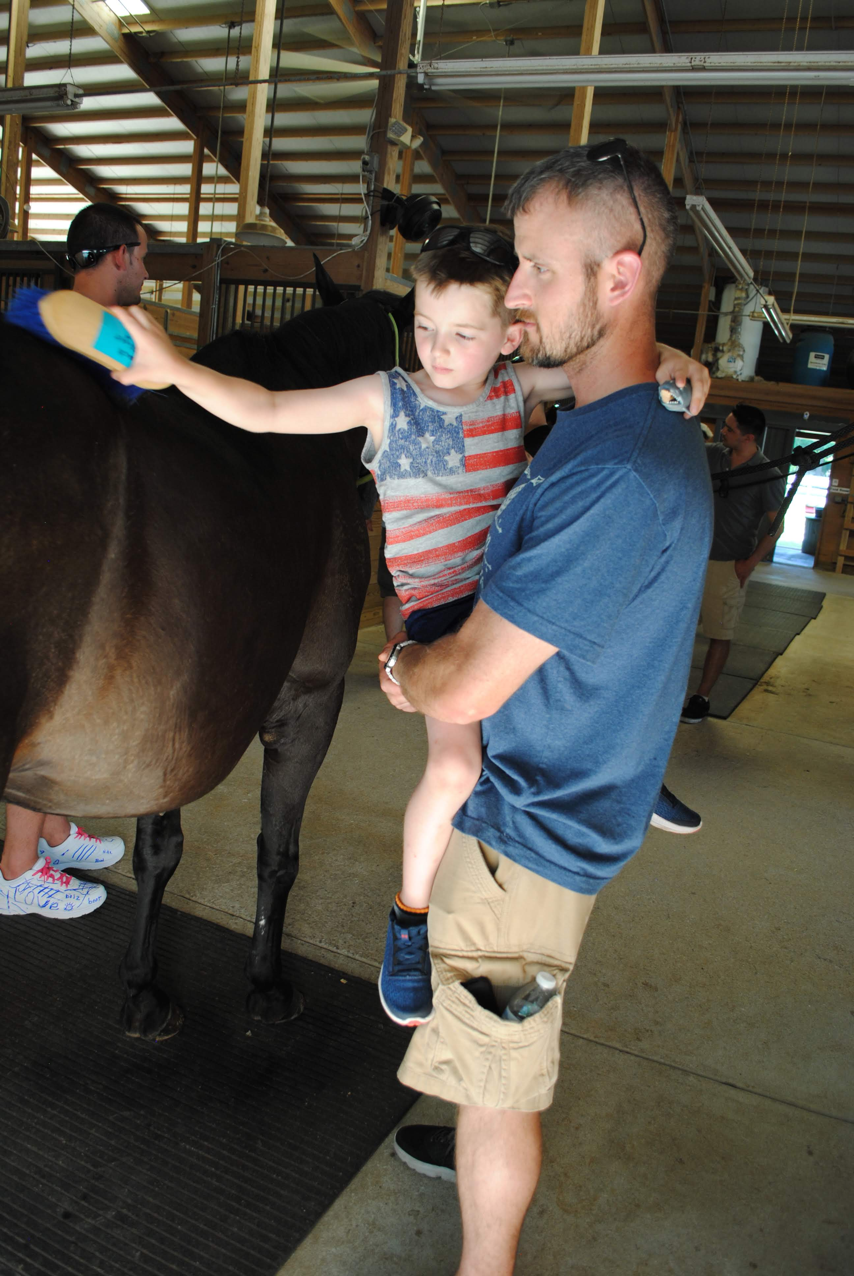

Cpl. Anthony Clay Ward Program for Veterans
Participants in this program are veterans, active or inactive military personnel, and their families. The activities for this program vary and are determined by the individuals or groups attending.

VOLUNTEER CODE OF ETHICS
The Red Barn seeks to provide a safe, peaceful, and professional environment for students, visitors, staff members, volunteers, and horses. The purpose of this code of ethics is to provide volunteers with an ethical and responsible framework from which to serve.
As a volunteer, I will:
- Listen carefully to The Red Barn staff members and recognize that they follow certain procedures for a reason.
- Respect my fellow volunteers.
- Strive to keep the Executive Director or Public Relations Coordinator informed of opportunities in the community for promoting The Red Barn and potential funding opportunities.
- Keep well informed of developments and policies relevant to my volunteer responsibilities and The Red Barn policies. I understand that email is the preferred method of communication.
- Participate actively in volunteer trainings and assist other volunteers as they join The Red Barn.
- Bring to the attention of the Executive Director or Assistant Director any issues that I believe will have an adverse effect on the organization or those we serve.
- Help curtail any negative conversations, rumors or gossip.
- Consider myself as having a vested interest in the organization and do my best to ensure that it is well maintained - keeping quality and safety in mind.
- Always strive to learn how to be a more effective volunteer, while also assisting the staff in improving the volunteer program.
10.Notify staff if I cannot physically do something that is asked of me.
As a volunteer, I will not:
- Criticize fellow volunteers and staff members or their opinions.
- Use the organization for my personal advantage or that of my friends or relatives.
- Discuss confidential issues with anyone not involved with those issues.
- Interfere with the duties of staff members or undermine their authority.
- Mistreat horses or any other animals on The Red Barn property in any fashion.
- Take pictures or videos while on Red Barn property.
Where repeated attempts have been made to rectify a volunteer's non-compliance with the Code of Ethics, or where a severe violation of the Code of Ethics has occurred, prompt action will be taken to remove or suspend the individual. As a Red Barn volunteer, I agree to adhere to and to be responsible for maintaining the above Code of Ethics.
Signed: ________________________________________Date: __________________

BARN RULES
- No smoking anywhere on the premises.
- Please drive slowly; we love our children and horses.
- Direct access to any horse must be supervised by one of our instructors.
- Closed-toe shoes are required when working with horses.
- Safety stirrups or boots are required when on a horse.
- Helmet is required when riding.
- Observe all "off limits" signs.
- No one is allowed in the red house or the brick house without permission.
- No one should be on Red Barn property without permission.
- No "horse play" in the barn (roughhousing).
- Parents must supervise all students who are not in a lesson.
- No dogs or other pets.
- Please flush only toilet paper down the toilets on the property (no wipes or feminine products).

Tracking Hours
Logging hours is the Volunteer's responsibility, but we have a few options for you to choose from to make it convenient.

- You can sign-in on the sign-in sheet in the lower barn. This will get recorded weekly to help keep track of community support
- Log your hours on your phone by using the Track it Forward App. Please see the directions below.
  - You must first create an account by going to the website. https://www.trackitforward.com/site/red-barn
  - Once that's complete, you can then download the app to log your hours easily.
    - Open your app store.
    - Search and download Track it Forward.
    - Log in
    - Log hours

Please email grace@theredbarn.org if you have any questions or to confirm the total hours served when needed for school or work.
Volunteer Program

- Those 16 years of age and older have several volunteer opportunities.
- There is something for almost everyone - those with horse experience and those without.
- All volunteers 19 and older must pass a DHR child abuse/neglect check, and all volunteers 18 and older must pass a criminal background check.
- Volunteers may discontinue their service at any time, but advance notice is greatly appreciated. The Red Barn has the right to discontinue any volunteer service that fails to follow a given code of ethics or breaches confidentiality.
- Attending a volunteer orientation is required for all who wish to volunteer at The Red Barn.
- Please be mindful of your physical limitations and do not cause injury to yourself, others, or The Red Barn property while volunteering.
- Volunteers are here to assist in giving the participants the best service. This means that there should be no expectation of "horse time" or care. The horses are here to serve the participants of The Red Barn, and volunteers make that safe and enjoyable for the participant.
- As of August 2021, The Red Barn requires that volunteers are fully vaccinated.

Equal Opportunity Policy: The Red Barn maintains a strong policy of equal volunteer opportunity. We recruit, accept, train, promote and dismiss volunteers on the basis of personal competence and position performance, without regard to race creed, color, religion, sex, sexual orientation, age, marital status or handicap.
Volunteer Rights and Responsibilities: Volunteers are viewed as a valuable resource to this organization, its staff, and its clients. Volunteers shall be extended the right to be given meaningful assignments, the right to be treated fairly, the right to effective supervision, the right to full involvement and participation, and the right to recognition for work done. In return, volunteers shall agree to actively perform their duties to the best of their abilities and to remain loyal to the goals and procedures of the agency.
Grievance Procedure: Volunteers and staff are expected to act professionally and in accordance with their position descriptions. Should a volunteer have a grievance concerning their work environment, they should report it promptly to the Volunteer Coordinator or the Executive Director. Every effort will be made to achieve speedy and effective resolution, and all complaints will be treated confidentially. Confidentially may not be guaranteed for complaints involving sexual harassment or child abuse.
Alcohol/Drugs: When participating in The Red Barn activities, volunteers are prohibited from purchasing, transferring, using or possessing illicit drugs, alcohol, or prescription drugs in any way that is illegal. Implementing this policy provides a drug and alcohol-free work place in order to ensure a safe, healthy, and productive environment for all volunteers and employees. If caught or suspected of breaking this policy, disciplinary actions up to and including termination will result.
Harassment Policy: Volunteering should be an enjoyable experience. Harassment is not only illegal, but it also creates uncomfortable conditions and unpleasant experience for everyone involved. Any volunteer who feels harassed should speak to his/her volunteer supervisor or the executive director in attempt to reach a solution.
Media Policy: Please be careful not to represent yourself as a spokesperson or representative for the organization under any circumstances without prior approval. Only the executive director, approved staff and/or board members may serve as spokes people for The Red Barn.

Volunteer Positions Descriptions

Barn and Property Maintenance Volunteers
Volunteers may clean buckets, help feed and water horses, clean tack, muck stalls (without horses inside), or work on projects around the barn like lawn maintenance, gardening, stick removal, repair of broken equipment, and special projects. Barn and Property Maintenance Volunteers will only be scheduled when a staff person is present and available to supervise them, regardless of age or experience.

Helping Kids
Volunteers perform various tasks, such as assisting with arts and crafts, keeping an eye on children to ensure safety, serving food, help to tack up and grooming horses, help leading and sidewalking while participants ride, and much more. The staff also depend on volunteers to make sure kids are engaged and involved in the classes and lessons. Previous horse experience is not required to assist with these programs. Consistency is essential for the success of our students. Volunteers are asked to make a weekly commitment of at least one hour at the same time each week, per 10-week term.

Ambassador Volunteers
Volunteers are the most prominent advocates for The Red Barn. We have a team of volunteers advocating for The Red Barn daily by spreading the mission of The Red Barn through sharing social media posts and looking for opportunities to speak to groups and organizations. They also help plan a few fundraisers each year and miscellaneous other events, like holiday parties. Each event requires planning, donation solicitation, set up, clean up, and evaluation. Volunteers are welcomed and encouraged to volunteer on event committees. Contracts for services should only be signed by Red Barn staff, and no funds should be promised or spent without prior consent by a Red Barn staff member.

Supply Drive Volunteers
The Red Barn always needs items like bottled water, paper products, office supplies, arts and crafts supplies, snacks, or tack, and other equipment required for the horses. Volunteers are welcomed and encouraged to collect these items in the community for donation to The Red Barn. Having these items donated by supporters allows us to use a greater percentage of budgeted funds for our programs. A Red Barn staff member should be consulted before approaching any businesses for donations before beginning a campaign for supplies. See the back page of the manual for The Red Barn's wish list.

Frequently Asked Questions
When can I begin volunteering?
After completing training, many volunteers are incredibly anxious to get started! While we would love to incorporate everyone as quickly as possible, it takes time to place new volunteers in the programs. Please be patient during this process and know that we're doing our best to get everyone involved as soon as possible.
What do I do when I arrive at The Red Barn the first time to Volunteer? Before arriving, be sure to know where your event or lesson is going to take place. If it is on the red barn property, you will park in the gravel parking area or the grass across the drive. If you are to meet at the white barn, please drive up the gravel drive and enter the gate. Parking areas are marked. In both areas of our property, there is a sign-in book. Please log your hours with us!
Why do I have to sign in?
Signing in is very important because tracking volunteer hours will help us secure funding and show potential donors the tremendous community support we have. It also allows us to report your served hours back to you accurately. See section Tracking Hours for details.
Can I become friends with the students and/or their parents?
You are likely to feel a special connection with students. However, please refrain from giving money or gifts to the students, offering rides or other personal favors, and giving out personal contact information. You are cautioned to consider the consequences before connecting with parents or guardians on any social media site. Please contact a staff member if you feel like a student and/or their family has a significant need. Be a support person in their lives while at the barn and know that you are making an eternal difference even if you are only with them for a short time.
Will someone inform me of the student's reasons for participating in The Red Barn's programs?
Many of our participants have physical, cognitive, or emotional disabilities. They want to be spoken to with respect; they don't want to be questioned or made to feel uncomfortable. They want to learn and have a good time, and they want to spend time with horses! Do not expect to be told the participant's circumstances for being at The Red Barn. Please do not ask prodding or inappropriate questions, and please let a staff member know if you are uncomfortable working with children with a specific disability.

Why is the student I'm working with progressing so slowly?
At The Red Barn, the pace is a bit slower than traditional barns. This is a low-stress, encouraging, uplifting, peaceful, and educational environment on purpose. Please help us keep this atmosphere by encouraging the riders, listening when they would like to talk, giving positive feedback, and treating everyone the way you want to be treated.

Will I be notified if a student cancels?
Occasionally, students will cancel their lesson at the last minute or not show up at all. This is inevitable. If the student you are scheduled to assist cancels or does not show up, please ask a staff person if there is anything else that you can do. Chances are pretty good that there are other tasks to be done! The barn will contact you upon hearing a student has canceled.
Flexibility and understanding are greatly appreciated.
What is the weather policy?
The weather also affects the lesson schedule at the barn. Please do not assume that lessons are canceled due to rain. We may use the opportunity to do groundwork with the students. If it is thundering and lightning, students will not be allowed to work with the horses. If you feel like traveling from where you are to The Red Barn is dangerous, please text the barn to let us know.
Every effort will be made to notify volunteers of cancellations in advance. Again, your flexibility and understanding are greatly appreciated!
When am I allowed to take pictures/videos?
Volunteers are encouraged to give their full attention to the student they are working with or the task they are volunteering. The Red Barn must be a safe place for our students and their families. Please do not take pictures or videos of our students or their families. This is very important! If you need photographs for a school project or advocate for the community's agency, please ask a staff member.
Is there a dress code for volunteers?
It is required that volunteers wear closed-toe shoes or boots that offer foot protection. We strongly advise against volunteers wearing dangling jewelry, perfume. Clothing and overall appearance should be modest, professional, safe, and allow duties to be accomplished easily.
How can I stay informed about The Red Barn's schedule and upcoming events?
The best way to stay up to date is to provide an accurate email address on your volunteer application. An email is sent out monthly with that month's volunteer opportunities. You will also receive emails throughout the month with other requests to help. You are welcome to contact the Volunteer Coordinator through email at any time. Connecting with us on Facebook, Twitter, and Instagram (TheRedBarnAL) is another excellent way to stay informed.

Most Common Disabilities
- Autism Spectrum Disorder: Autism spectrum disorder (ASD) is a neurological and developmental disorder that begins early in childhood and lasts throughout a person's life. It affects how a person acts and interacts with others, communicates, and learns. It includes what used to be known as Asperger syndrome and pervasive developmental disorders.
- Cerebral Palsy: Many non-progressive motor disorders with impairment of voluntary movement. May have restricted movement in one or more limbs. 3. Down Syndrome: Impaired mental ability accompanied by weak muscle tone.
- Intellectual Disabilities/Developmental Delays: The learning process will be slow and will depend on the severity of the disability. These riders learn by repetition. Consistency is important along with age appropriateness. In other words, treat them as their age dictates.
- Muscular Dystrophy: Progressive degeneration of muscle strength with no mental impairment. Becomes overly tired easily. Muscle strengthening is not possible.
- Multiple Sclerosis: Wide range of symptoms and characteristics. Muscle weakness, lack of judgement or inattention. Avoid over fatiguing.
- Seizures: Seizures can be associated with various disabilities. The rider may appear non-coherent suddenly or appear vacant immediately before a seizure occurs. Call the instructor's attention to the rider immediately if this is suspected.
- Reactive Attachment Disorder: Characterized by significantly disturbed and developmentally inappropriate ways of interacting in most social circumstances.
- Fetal Alcohol Syndrome: The main effect of Fetal Alcohol Syndrome is permanent central nervous system damage, especially to the brain. Effects can include poor memory, attention problems, impulsive behavior, poor cause-effect reasoning, and distinctive facial features.
- Anxiety Disorders: A mental disorder characterized by excessive feelings of anxiety and fear. These feelings may cause physical symptoms such as racing heart and shakiness.
- Dyslexia: Characterized by a difficulty learning to read fluently or comprehend the material being read, despite normal intelligence.
- ADHD: A neurodevelopmental disorder characterized by problems with inattention, hyperactivity and/or acting impulsively that are inappropriate for the person's age.
- Post-Traumatic Stress Disorder (PTSD): PTSD may develop after a person is exposed to one or more traumatic events in which they experience intense fear, horror, or powerlessness. The diagnosis may be given when a group of symptoms, such as disturbing recurring flashbacks, avoidance or numbing of the memories of the event and hyper-arousal continue for more than a month after the traumatic event.

Sidewalking
When a volunteer is sidewalking, their sole responsibility is the rider to which they are assigned. They stay aware of their rider by watching their balance and expressions. The sidewalker will receive instructions from the lesson instructor and should follow those instructions strictly. The ideal position for a sidewalker is to stay between the rider's knee and hip and about 4-6 inches away. Sidewalkers do not need previous horse experience, but will be required to complete volunteer training at The Red Barn. Sidewalkers must be physically capable of holding the sidewalking position for 30 minutes at a time and walking and/or trotting with their rider.

During the lessons/sessions, the primary responsibility of a sidewalker is to ensure the student's safety.
- Try to avoid unnecessary talking with the student and other volunteers during the lesson/session. Too much input can be confusing and distracting to the student.
- Maintain your position at the student's knee.
- When the instructor/therapist gives instruction, allow the student plenty of time to process that instruction.
- Each student is different and has different goals. Feel free to ask if you are unsure! The instructor/therapist will give you direction as to the level of help you should give for your student.
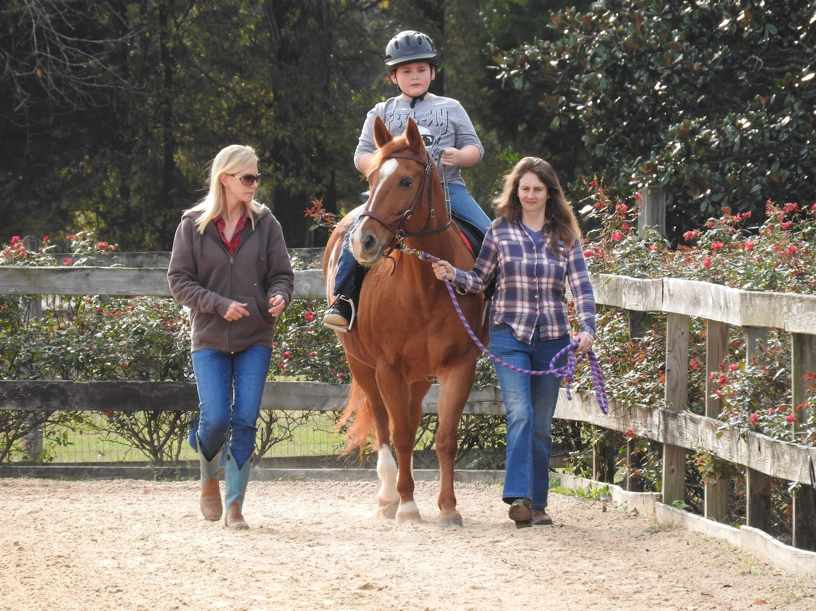

Types of holds
Hand over thigh – grip the front of the saddle (flap or pommel) with the hand closest to the student, and gently rest your forearm on the student's thigh.

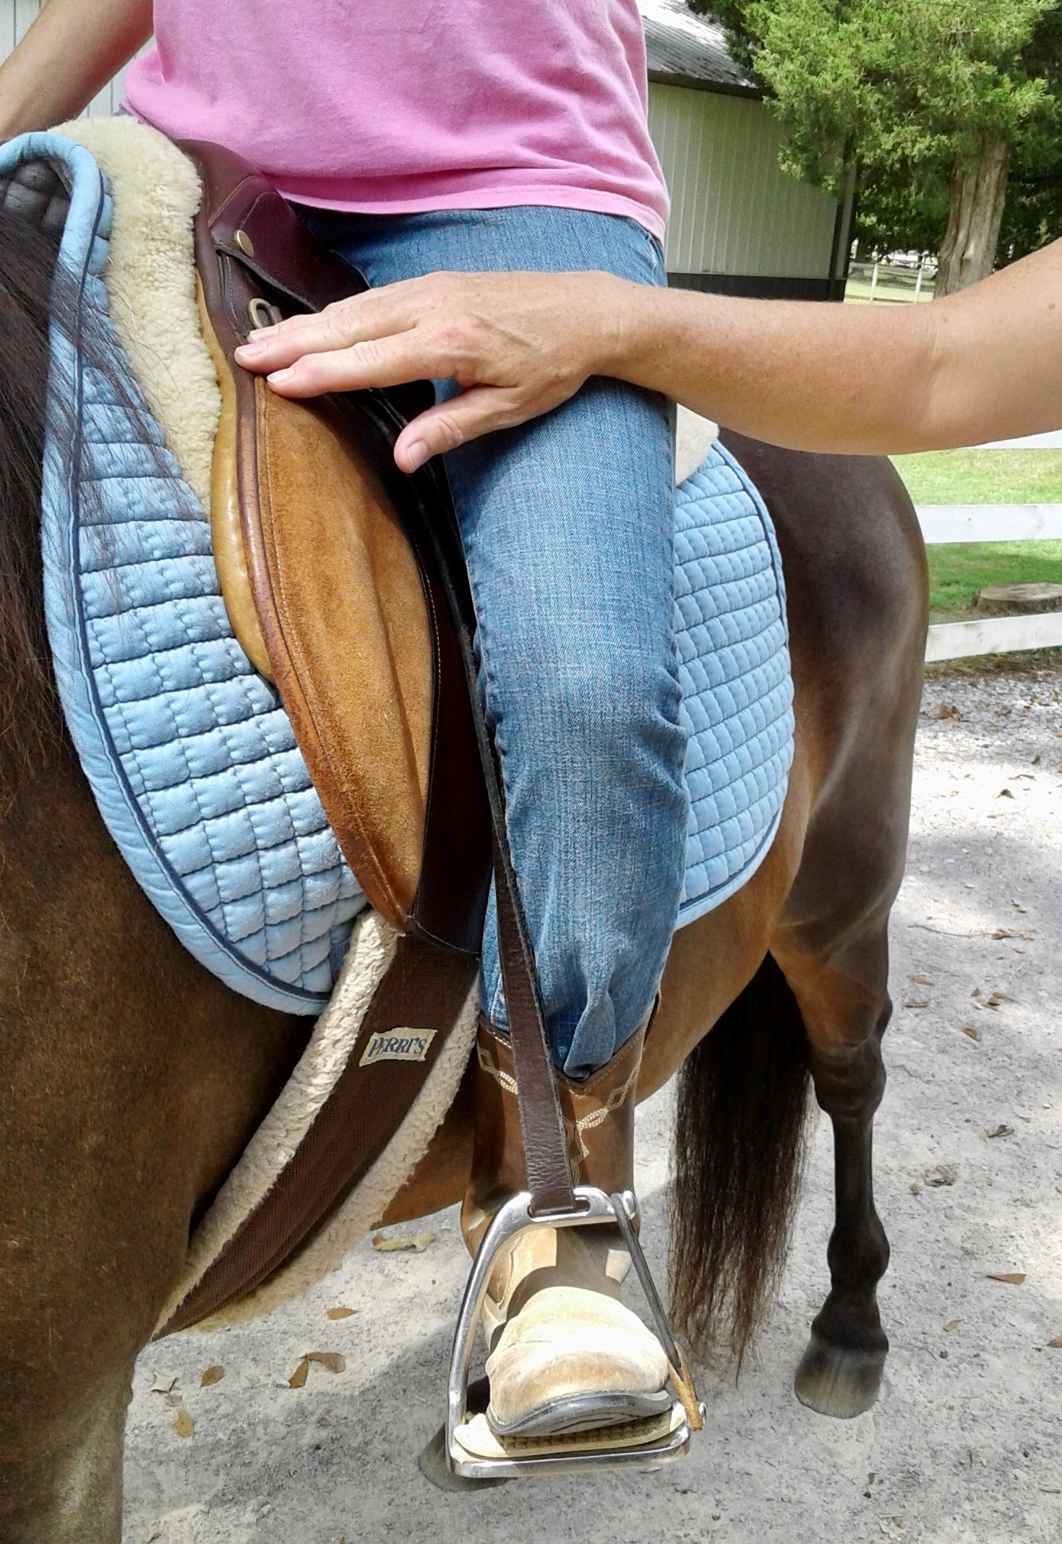
Front Ankle – place hand in the front of the ankle, typically used to ensure proper leg position
Back Ankle – place a hand on the back of ankle/heel, avoid ankle tendon, typically used to ensure the student isn't digging into horse and/or as a reminder to hold heels down for balance
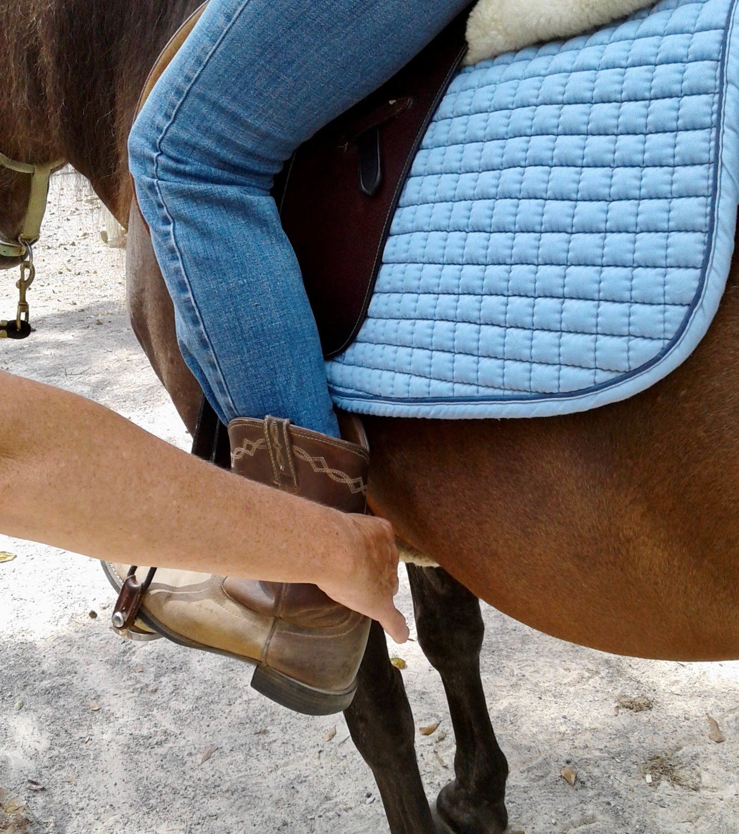

Horse Handling: When a volunteer is leading a horse, their sole responsibility is the horse which they are leading. They are always tuned in to what their horse is doing and, when needed, giving verbal feedback to the instructor about how their horse is behaving.
Horse Handler Evaluation: All volunteers wishing to be Horse Handlers must complete and pass The Red Barn's Horse Handler Evaluation. You must have completed at least one term as a volunteer (either in the riding lesson program or as a barn volunteer) before you can be considered for evaluation. Horse Handler Evaluations are scheduled at the discretion of our instructors. Evaluations typically last about one hour.
Spotting: When a volunteer is spotting, they are asked to watch a horse and rider team. They are to verbally inform the instructor of any concerns about the horse and rider team and intervene if the situation becomes hazardous. While this position does not seem "busy" or even necessary at times, please understand that it is very important for the safety of everyone involved for you to remain attentive.

Jobs within the Mounting Process
Horse Handler: When mounting, the horse handler's job is to align the horse's body as close to the mounting ramp as possible without rubbing the saddle against the wood, as well as keeping the horse still and calm throughout the entire mounting process.
- Hold horse outside of ramp until instructor has performed a safety check and given you permission to enter the ramp.
- Lead the horse in the ramp while keeping his body close to the ramp (2-4 in.).
- Standing beside the horse, keep him quiet and still while instructor mounts the student.
- Once given verbal permission by the instructor, walk horse straight out of the ramp. Reason being, the instructor/sidewalker will have a handhold on the student the entire way out of the ramp.
- After approximately 4-6 steps the instructor will ask you to halt the horse. They will then adjust stirrups and give you further instructions.
Offside Guide: During the mounting process, the sidewalker's job is to stand on the offside of the horse (right side), either on the ground or on the ramp. You will act as a barrier to the horse as well as assist the instructor in mounting the student.
- Before the horse enters the ramp, the instructor will ask you to take your place standing on the offside.
- Once the horse is standing quietly, the instructor will begin mounting the student. Your job is to assist her by supporting the right leg as it comes over the back of the horse or weighting the stirrup as directed.
- After the student is seated, the instructor will tell you what hold to do and will ask the leader to exit the ramp. You are to walk forward with the designated handhold on your student.
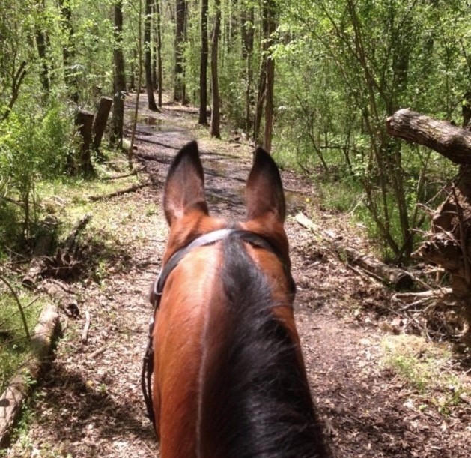
Emergency Procedures

Although the staff does their best to keep any danger from coming to any students, there is always the possibility that something may happen. During an emergency, there are a few things to remember. Above all else, please stay calm.
There is a phone to dial 911 next to the green couch in the red barn, in the office of the red house, white house, and in the white barn office.

Emergency Procedures During a Riding Lesson
- Horse Handler: Your job is to take care of your horse. In any situation, you are never to let go of your horse. If ever there is an emergency with your student, you are to halt your horse and calm him.
  - If the student is still mounted, stop the horse and calm it. Your sidewalker will notify the instructor of an emergency and will care for your student. The instructor will give you further information once the student is dismounted.
  - If your student has fallen, the sidewalker will notify the instructor and you are to move the horse out of the way with the horse's hindquarters pointing away from the student.
  - If you do not have a sidewalker present, stop your horse, verbally notify an instructor, and try to support your student. If the student has already fallen, move your horse away from the student and call on the instructor.
- Sidewalkers: Your job is to care for the student. In any situation, you are to verbally notify the instructor and take charge of your student. Two possible ways is to do this is by either holding your student on the horse or performing an emergency dismount.
If there is an emergency with another horse and student team in the arena or on the trail with you, all other horse and rider teams should stop their horses, remain calm, and wait for further instruction from your instructor.
Horse Handlers – NEVER let go of your horse's rope for any reason!
Sidewalkers – NEVER leave your student for any reason!

THE RED BARN'S WISHLIST
Many of these items are available for purchase online through our Amazon Wish list.
Bottled water
Forever stamps
Paper towels
Toilet paper
Kleenex
Individually packaged snacks
Shampoo
Trash bags
Batteries
Art supplies
Cleaning supplies
Office supplies
Hand soap
Hand lotion

